# Background

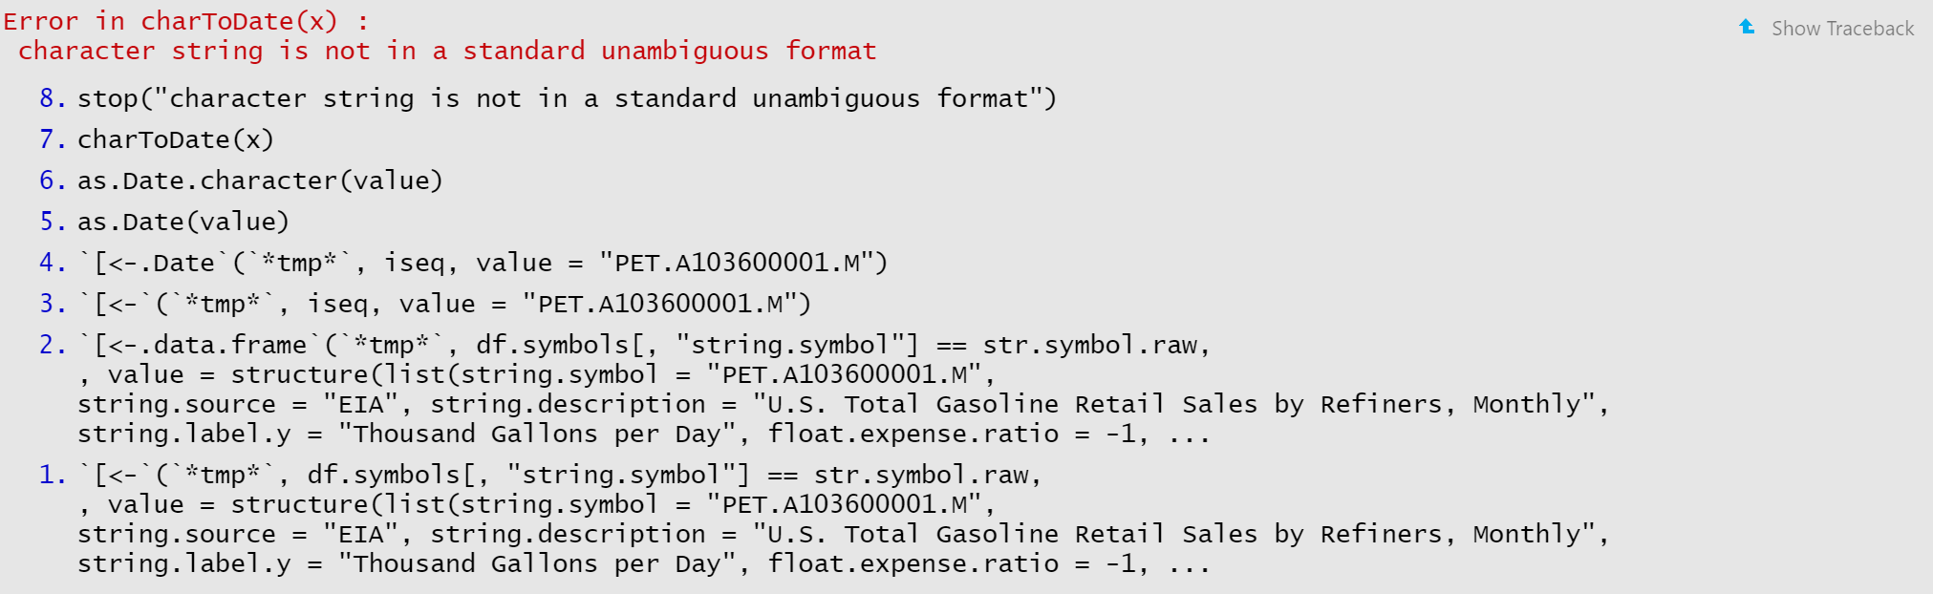

This seems to be the offending line

df.symbols[df.symbols[, "string.symbol"] == str.symbol.raw, ]$date.series.start = tail(df.temp$Date, 1)

Seems to be calling the wrong object. df.temp was assigned to a gold series earlier:

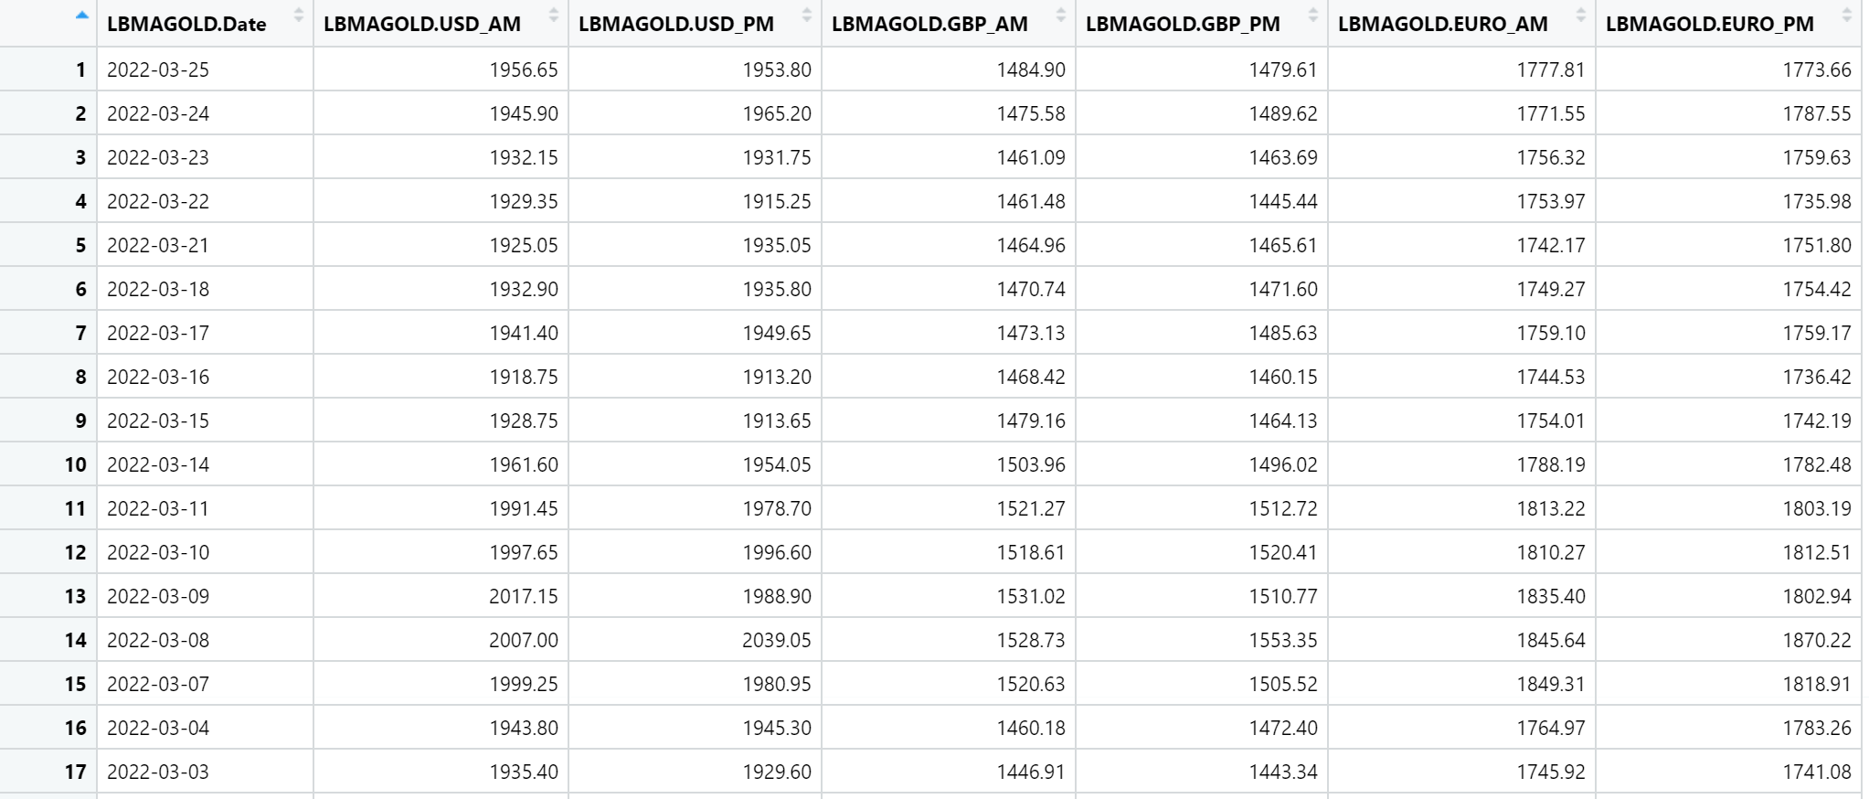

I removed the incorrect reference and used the safe string name:

df.symbols[df.symbols[, "string.symbol"] == str.symbol.raw,]$date.series.start = tail(index(get(str.name)), 1)

df.symbols[df.symbols[, "string.symbol"] == str.symbol.raw,]$date.series.end = index(get(str.name))[[1]]